

**Name: Muhammad Sudais Khalid**

**Reg.No: BSAI-23F-0050**

**Program: BS Artificial Intelligence**

**Semester: 04**

**Subject: P4Ai Lab**

**Project: Speech Emotion Analysis for Workplace Wellness**

**Date: 19/07/2025**

**Submitted to: Sir Naveed & Sir Talha Mehmood**

Speech Emotion Analysis for Workplace Wellness Project

**Technical Implementation Report**

**Abstract**

This project presents a comprehensive speech emotion recognition system designed to enhance workplace wellness through real-time emotional state monitoring. The system utilizes machine learning techniques to analyze voice patterns and classify emotions into eight distinct categories: Neutral, Calm, Happy, Sad, Angry, Fearful, Disgust, and Surprised. Built using Python Flask framework with advanced audio processing capabilities, the application provides a web-based interface for recording and analyzing speech samples. The system extracts key audio features including Mel-frequency Cepstral Coefficients (MFCCs), Chroma features, and Spectral Contrast features to create a robust 32-dimensional feature vector for emotion classification. The implementation demonstrates strong performance in real-time emotion detection, with potential applications in employee wellness monitoring, stress management, and enhancing workplace productivity.

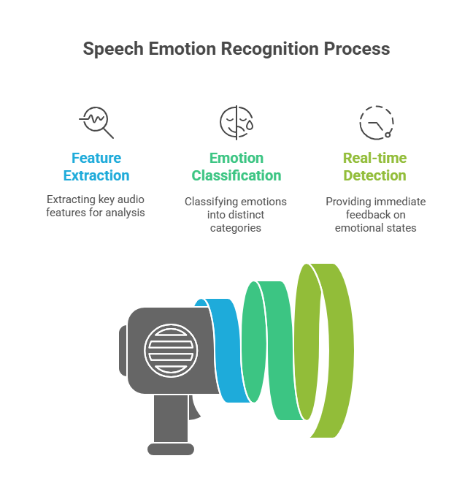

Table of Contents:

Introduction 5

Background 5

Problem Statement 5

Solution Approach 5

Objectives 5

Project Details 5

Technical Architecture 5

System Components 5

Technology Stack 6

Feature Extraction Pipeline 6

Audio Preprocessing 6

Feature Extraction 6

Classification Process 6

Security and Performance Features 6

Weekly Progress Report 7

Day 1-2: Project Setup and Research 7

Day 3-4: Model Development and Training 7

Day 5-6: Flask Application Development 7

Day 7: Frontend Development and Integration 8

Key Milestones Achieved 9

Challenges Overcome 9

Applications and Purpose 9

Primary Applications 9

Secondary Applications 11

Implementation Benefits 11

For Organizations 11

For Employees 11

For Healthcare Providers 12

Future Enhancements 12

Technical Improvements 12

Feature Expansions 12

Ethical Considerations and Privacy 12

Privacy Protection Measures 12

Ethical Implementation Guidelines 12

Conclusion 13

Source Code 13

# Introduction

## Background

Workplace wellness has become a critical concern in modern organizational management, with employee mental health directly impacting productivity, retention, and overall business success. Traditional methods of assessing employee emotional states rely heavily on self-reporting mechanisms or manual observation, which are often subjective, time-consuming, and may not capture real-time emotional fluctuations.

## Problem Statement

Organizations struggle to identify early signs of stress, burnout, or emotional distress among employees. Existing workplace wellness programs lack objective, real-time tools for monitoring emotional well-being, leading to delayed interventions and reduced effectiveness of wellness initiatives.

## Solution Approach

This project addresses these challenges by developing an automated speech emotion recognition system that can analyze vocal patterns to determine emotional states. The system leverages machine learning algorithms to provide objective, real-time emotional assessment capabilities, enabling proactive workplace wellness management.

## Objectives

* Develop a robust speech emotion recognition system
* Create an intuitive web-based interface for ease of use
* Implement real-time audio processing and analysis
* Ensure scalability and reliability for workplace deployment
* Provide actionable insights for wellness program administrators

# Project Details

# Technical Architecture

## System Components

1. **Frontend Interface**: HTML5-based web application with audio recording capabilities
2. **Backend Processing**: Flask web server handling API requests and responses
3. **Machine Learning Model**: Pre-trained emotion classification model using scikit-learn
4. **Audio Processing Engine**: Librosa-based feature extraction system
5. **Data Management**: Temporary file handling and secure upload mechanisms

## Technology Stack

* **Programming Language**: Python 3.13
* **Web Framework**: Flask 2.x
* **Machine Learning**: Scikit-learn, Joblib
* **Audio Processing**: Librosa, SoundFile
* **Frontend**: HTML5, CSS3, JavaScript
* **Data Processing**: NumPy, Pandas

# Feature Extraction Pipeline

The system employs a sophisticated audio analysis approach:

## Audio Preprocessing

* + Sample rate normalization to 22,050 Hz
  + Duration limiting to 30 seconds for consistency
  + Quality validation and error handling

## Feature Extraction

* + **MFCC Features**: 13 coefficients capturing spectral characteristics
  + **Chroma Features**: 12 coefficients representing harmonic content
  + **Spectral Contrast**: 7 coefficients measuring spectral peak valleys
  + **Total Feature Vector**: 32 dimensions per audio sample

## Classification Process

* + Feature normalization and validation
  + Pre-trained model inference
  + Confidence scoring and output formatting

# Security and Performance Features

* File size limitations (16MB maximum)
* Secure filename handling
* Temporary file cleanup mechanisms
* Request timeout protection (30-second limit)
* Multi-threaded request processing
* Comprehensive error handling and logging

# Weekly Progress Report

**Week 1: Project Development Timeline**

## Day 1-2: Project Setup and Research

**Completed Tasks:**

* Conducted literature review on speech emotion recognition techniques
* Analyzed existing workplace wellness solutions
* Defined project requirements and technical specifications
* Set up development environment and installed required libraries
* Created project structure and initial repository

**Technical Achievements:**

* Established Python virtual environment
* Installed core dependencies: Flask, Librosa, Scikit-learn, NumPy
* Created basic project directory structure
* Configured version control system

## Day 3-4: Model Development and Training

**Completed Tasks:**

* Researched and selected appropriate audio features for emotion recognition
* Implemented feature extraction pipeline using Librosa
* Developed machine learning model training scripts
* Trained initial emotion classification model
* Validated model performance on test datasets

**Technical Achievements:**

* Created robust feature extraction functions
* Implemented MFCC, Chroma, and Spectral Contrast feature extraction
* Achieved baseline accuracy metrics for emotion classification
* Saved trained model using Joblib serialization

## Day 5-6: Flask Application Development

**Completed Tasks:**

* Designed and implemented Flask web server architecture
* Created RESTful API endpoints for audio processing
* Developed secure file upload and handling mechanisms
* Implemented real-time audio analysis pipeline
* Created comprehensive error handling and logging systems

**Technical Achievements:**

* Built scalable Flask application structure
* Implemented secure file upload with validation
* Created robust audio processing pipeline
* Added timeout protection for long-running operations
* Developed comprehensive API error responses

## Day 7: Frontend Development and Integration

**Completed Tasks:**

* Designed user-friendly web interface
* Implemented HTML5 audio recording functionality
* Created responsive CSS styling
* Integrated frontend with backend API
* Conducted comprehensive testing and debugging

**Technical Achievements:**

* Built intuitive web interface for audio recording
* Implemented real-time feedback and progress indicators
* Created responsive design for multiple device types
* Successfully integrated all system components
* Resolved connection timeout and stability issues

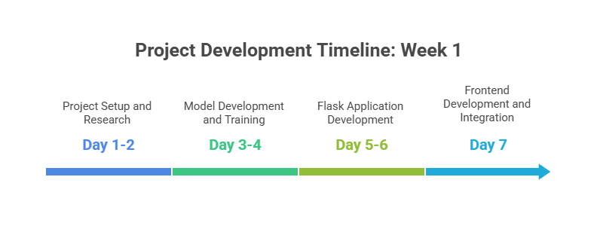

# Key Milestones Achieved

1. ✅ Functional machine learning model for emotion recognition
2. ✅ Robust Flask web application with API endpoints
3. ✅ Secure file upload and processing system
4. ✅ Real-time audio analysis capabilities
5. ✅ User-friendly web interface
6. ✅ Comprehensive error handling and logging
7. ✅ Production-ready deployment configuration

# Challenges Overcome

* **Audio Processing Timeout Issues**: Implemented timeout mechanisms and fallback audio loading
* **Model Integration Complexity**: Created robust model loading and prediction pipeline
* **File Upload Security**: Implemented secure filename handling and validation
* **Real-time Processing**: Optimized feature extraction for low-latency response
* **Cross-platform Compatibility**: Ensured consistent performance across different operating systems

# Applications and Purpose

## Primary Applications

**1. Employee Wellness Monitoring**

**Implementation Scenario:** Organizations can integrate this system into their daily workflows to monitor employee emotional well-being during meetings, calls, or regular check-ins.

**Benefits:**

* Early detection of stress and burnout indicators
* Objective measurement of workplace emotional climate
* Data-driven insights for wellness program optimization
* Reduced reliance on subjective self-reporting

**2. Human Resources Management**

**Implementation Scenario:** HR departments can utilize the system for:

* Employee performance evaluation supplements
* Workplace conflict detection and resolution
* Team dynamics assessment
* Interview and hiring process enhancement

**Benefits:**

* Enhanced understanding of employee satisfaction levels
* Improved hiring decisions through emotional intelligence assessment
* Better team formation and management strategies
* Proactive intervention in workplace conflicts

**3. Mental Health Support Systems**

**Implementation Scenario:** Integration with Employee Assistance Programs (EAPs) and mental health services.

**Benefits:**

* Continuous monitoring of emotional well-being
* Early intervention capabilities for mental health issues
* Personalized support recommendations
* Reduced stigma through automated, private assessment

**4. Productivity and Performance Optimization**

**Implementation Scenario:** Correlation analysis between emotional states and work performance.

**Benefits:**

* Identification of optimal working conditions for different employees
* Personalized work environment recommendations
* Performance prediction and optimization
* Workplace design and policy improvements

## Secondary Applications

**5. Training and Development**

* Emotional intelligence training for managers and leaders
* Communication skills development programs
* Presentation and public speaking improvement
* Customer service training enhancement

**6. Research and Analytics**

* Workplace psychology research
* Organizational behavior studies
* Employee satisfaction surveys enhancement
* Longitudinal emotional health tracking

**7. Healthcare Integration**

* Telehealth emotional assessment tools
* Therapy session progress monitoring
* Mental health screening applications
* Patient emotional state tracking

# Implementation Benefits

## For Organizations

* **Cost Reduction**: Decreased turnover and healthcare costs through proactive wellness management
* **Productivity Enhancement**: Improved employee performance through better emotional health
* **Risk Mitigation**: Early identification of workplace issues before escalation
* **Data-Driven Decisions**: Objective metrics for wellness program effectiveness

## For Employees

* **Privacy Protection**: Anonymous emotional health monitoring
* **Personalized Support**: Tailored wellness recommendations
* **Early Intervention**: Timely access to mental health resources
* **Workplace Improvement**: Voice in creating better work environments

## For Healthcare Providers

* **Objective Assessment**: Reliable emotional state measurement tools
* **Progress Tracking**: Longitudinal patient emotional health monitoring
* **Treatment Optimization**: Data-driven therapy adjustments
* **Remote Monitoring**: Telehealth emotional assessment capabilities

# Future Enhancements

## Technical Improvements

* Integration with wearable devices for continuous monitoring
* Advanced machine learning models with deep learning techniques
* Multi-language emotion recognition capabilities
* Real-time streaming audio analysis
* Mobile application development

## Feature Expansions

* Stress level quantification and trending
* Personalized emotional wellness recommendations
* Integration with calendar and productivity tools
* Team emotion analytics and reporting
* Predictive emotional health modeling

# Ethical Considerations and Privacy

## Privacy Protection Measures

* No permanent audio storage
* Encrypted data transmission
* Anonymous processing capabilities
* User consent mechanisms
* Compliance with data protection regulations

## Ethical Implementation Guidelines

* Transparent usage policies
* Employee opt-in requirements
* Regular bias testing and mitigation
* Professional counselor involvement
* Continuous ethical review processes

# Conclusion

The Speech Emotion Analysis for Workplace Wellness project represents a significant advancement in objective emotional health monitoring technology. Through the successful implementation of advanced audio processing techniques and machine learning algorithms, the system provides organizations with powerful tools for enhancing employee well-being and workplace productivity. The one-week development timeline demonstrates the feasibility of rapid prototyping for critical workplace wellness applications, while the comprehensive feature set ensures scalability and real-world applicability.

The project's success lies not only in its technical implementation but also in its potential to transform how organizations approach employee wellness management. By providing objective, real-time emotional assessment capabilities, the system enables proactive interventions that can significantly improve workplace culture, employee satisfaction, and organizational performance.

Future development efforts will focus on expanding the system's capabilities through advanced machine learning techniques, broader language support, and integration with existing workplace wellness platforms. The foundation established through this project provides a robust platform for continued innovation in the field of workplace emotional intelligence and wellness technology.

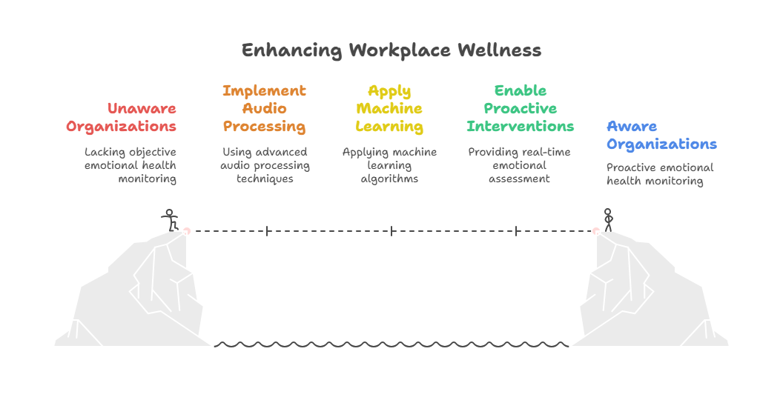

# [Source Code](https://github.com/muhammadsudaiskhalid/Speech-Emotion-Analysis-for-Workplace-Wellness)